**TASK 1**

HTTP Status code:

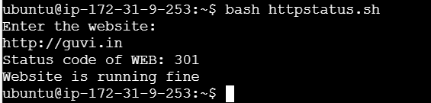

Eg2:

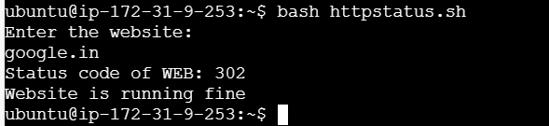

Bash script used:

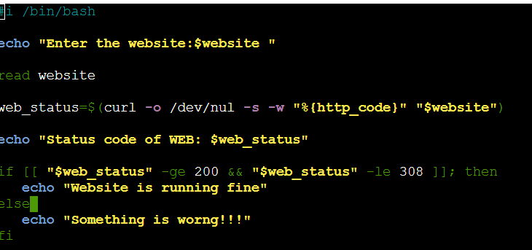

TASK 2

Replace the word:

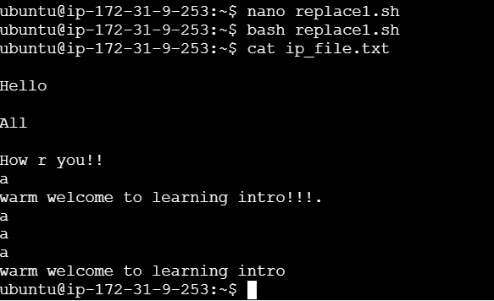

Script used:

